**CS5551 ADVANCED SOFTWARE ENGINEERING**

**PROJECT REPORT, PHASE – 4**

**Project Title:ROOKART**

**Project Owners:**

**1. Rajesh Gupta, Kollipara (21)**

**2. Sai Sriharsha Sudulaguntla (50)**

**3. Lava Kumar, Surparaju (52)**

**4. Raghu Pavan, Vallamkonda (54)**

**Index**

**1.0 Introduction**

**1.1 Phase - 4**

**2.0 Functionalities**

**2.1 Login Page**

**2.2 Register Page**

**2.3 Home Page**

**2.4 Products Page**

**2.5 Services Page**

**2.6 Sell Page**

**2.7 Post Add**

**3.0 Proposed System**

**4.0 Tool and Technologies**

**5.0 Development**

**6.0 Wire Frames**

**6.1 Login Page**

**6.2 Register Page**

**6.3 Home Page**

**7.0 Sequence Diagrams**

**8.0 Class Diagrams**

**9.0 State Diagram**

**10.0 Mock ups**

**11.0 Deployment**

**12.0 Project Management**

**13.0 Unit Testing**

**14.0 Bibliography**

**1.0 Introduction**

RooKart is an UMKC people group based e-business android application which engages Students and Staff individuals bearing a substantial enrolled UMKC Email id, to Sell or Buy Products, Offer Services, Post Classified Advertisements, Offer Deals on Demand and so on.

As every one of the exchanges and Product and Services are traded in the middle of the University related group High Reliability, Easy Shipping and Quality administrations are ensured.

When client is enrolled with RooKart, the client will ready to see, every one of the items and administrations at present accessible on the available to be purchased Such as Electronics, Furniture and so forth available to be purchased or Painting Classes, Fitness Class, Cooking Services and so on.

Client as a Seller can post their Products available to be purchased on Categorized Platforms gave by Rookart with the Complete history of the Product with pictures, Geo-area and Price sum and so on. So also, User can post every one of the administrations they wish to offer with finish depiction, pictures, valuing points of interest and span, geo-areas and so on.

This Project is isolated into four Iteration, every emphasis will enhance the usage highlights. The present cycle is Iteartion - 3/Phase – 3.

1.1 Phase –3 includes

1. Design and Implementation of the application with the Login Page, Registrartion

Page, Home Page, Products Page, Services Page, Seller’s Forum Page, Buyer Page.

2. UML Class Diagram, State Diagrams, Sequence Diagram, Wire Frames related to some of the above described functionalities.

2.0 Functionalities:

2.1 Login Page

Login Page is the landing page upon opening RooKart application, Login page lets the user to login upon succesfull validation of user credentials. User needs to input registerted email id and password. If the user does not have an account on RooKart, he should register.

2.2 Register Page

Register page collects the personal information of the user such as, User Name, Email ID, Password and Mobile Number and creates an account for the user.

2.3 Home Page

Once the user account is verified, Post Login user is redirected to this Home

Page, which offers the in app services as Products and Services.

Upon on selecting one the user is redirected to the Product/ Service Page.

2.4 Products Page: Products page Show the List view and Google map View of all the

Products posted for sale. Products are displayed as List in First Display manner.

Products can be viewed on the Google Map View, which shows the nearest available product to the user, based on his location using GPS Tracker.

2.5 Services Page: Services Page shows List View and Google map View of all available

Services posted.

Services can be viewed on the Google Map View, which shows the nearest available Service to the user, based on his location using GPS Tracker.

2.6 Sell Page: User who wants to Sell their Products and Services to the other people in the community can do by posting the details of the Product along with Images and complete description with their Location details, etc.

2.7 Post Add: Post Add enables the user to post the details inscribed by the user on the sell page to the list of all available Products/Services Pages on the buy Section.

3.0 Proposed System

3.1 Functional Requirement Specification: I. User Should have a sign in.

II. If User is new to RooKart User Should Register

III. User should be able to Provide info. IV. User details are need to be validated.

V. Upon Successful login User should see the Home Page – Product and Services

Page.

VI. Upon Choosing the Products, user will be navigated to Product view Page, user can select a product to read its complete description, user can contact the seller, user can buy the product.

VII: Upon Choosing the Service, user will be navigated to Product view Page, user can select a Service to read its complete description, user can contact the seller, user can buy the Service.

VIII: User can buy either of the services or Products, where mode of Transaction is still to be implemented.

IX: User can post the Products or Services which they would offer, along the complete description, Images, Location Details, etc.

4.0 Technologies and Tools:

I. ANDROID STUDIO

II. Front end: JavaScript

III. Programing Language: Java

IV. Creately

V: Canva

VI: Adobe Photoshop.

VII. MongoDB

5.0 Development

System Design

I. Login: Users login using their registered UMKC email address and password.

II. Registration: Collects the personal information of the user and creates an account. III. Information Collected: User Name, Email id, Password, Phone Number.

IV. Home page: Consists two buttons, Products, Services.

V. Products Page: List of Products, Buy option, Contact Seller.

VI: Service Page: List of Services or ADDs Posted, Buy option, Contact Seller option.

VII: Sell Page: User can post the ads related to the Products and Services they wish to offer along with the complete description, Location Details, Images etc.

6.0 Wire Frames

6.1 Login Page Wire Frame

Login page has two buttons, Login and Register. If the user is a new user to

Rookart he can register using the Register button.

Here is the Login Page Wire Frame.

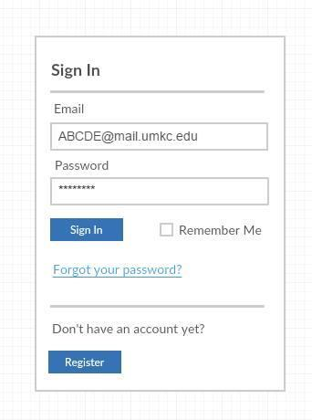

6.2 Registration Page

If the user is a new User he can Register on clicking Register button, Register Page collects the user’s personal information such as User Full Name, Email id, Password and Phone Number.

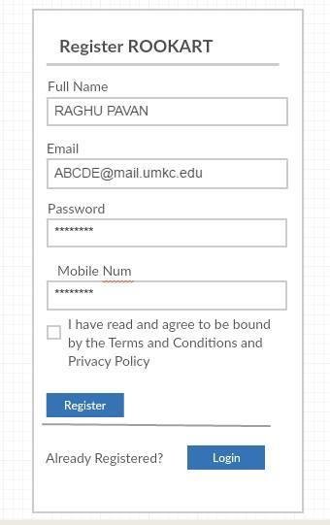

6.3 Home Page

Post the Login, the user is redirected to the Home Page. Home page consists of two buttons, Products and Services.

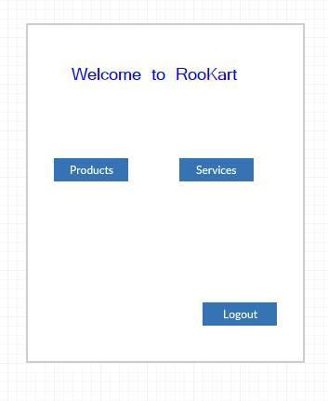

7.0 Sequence Diagram of the application:

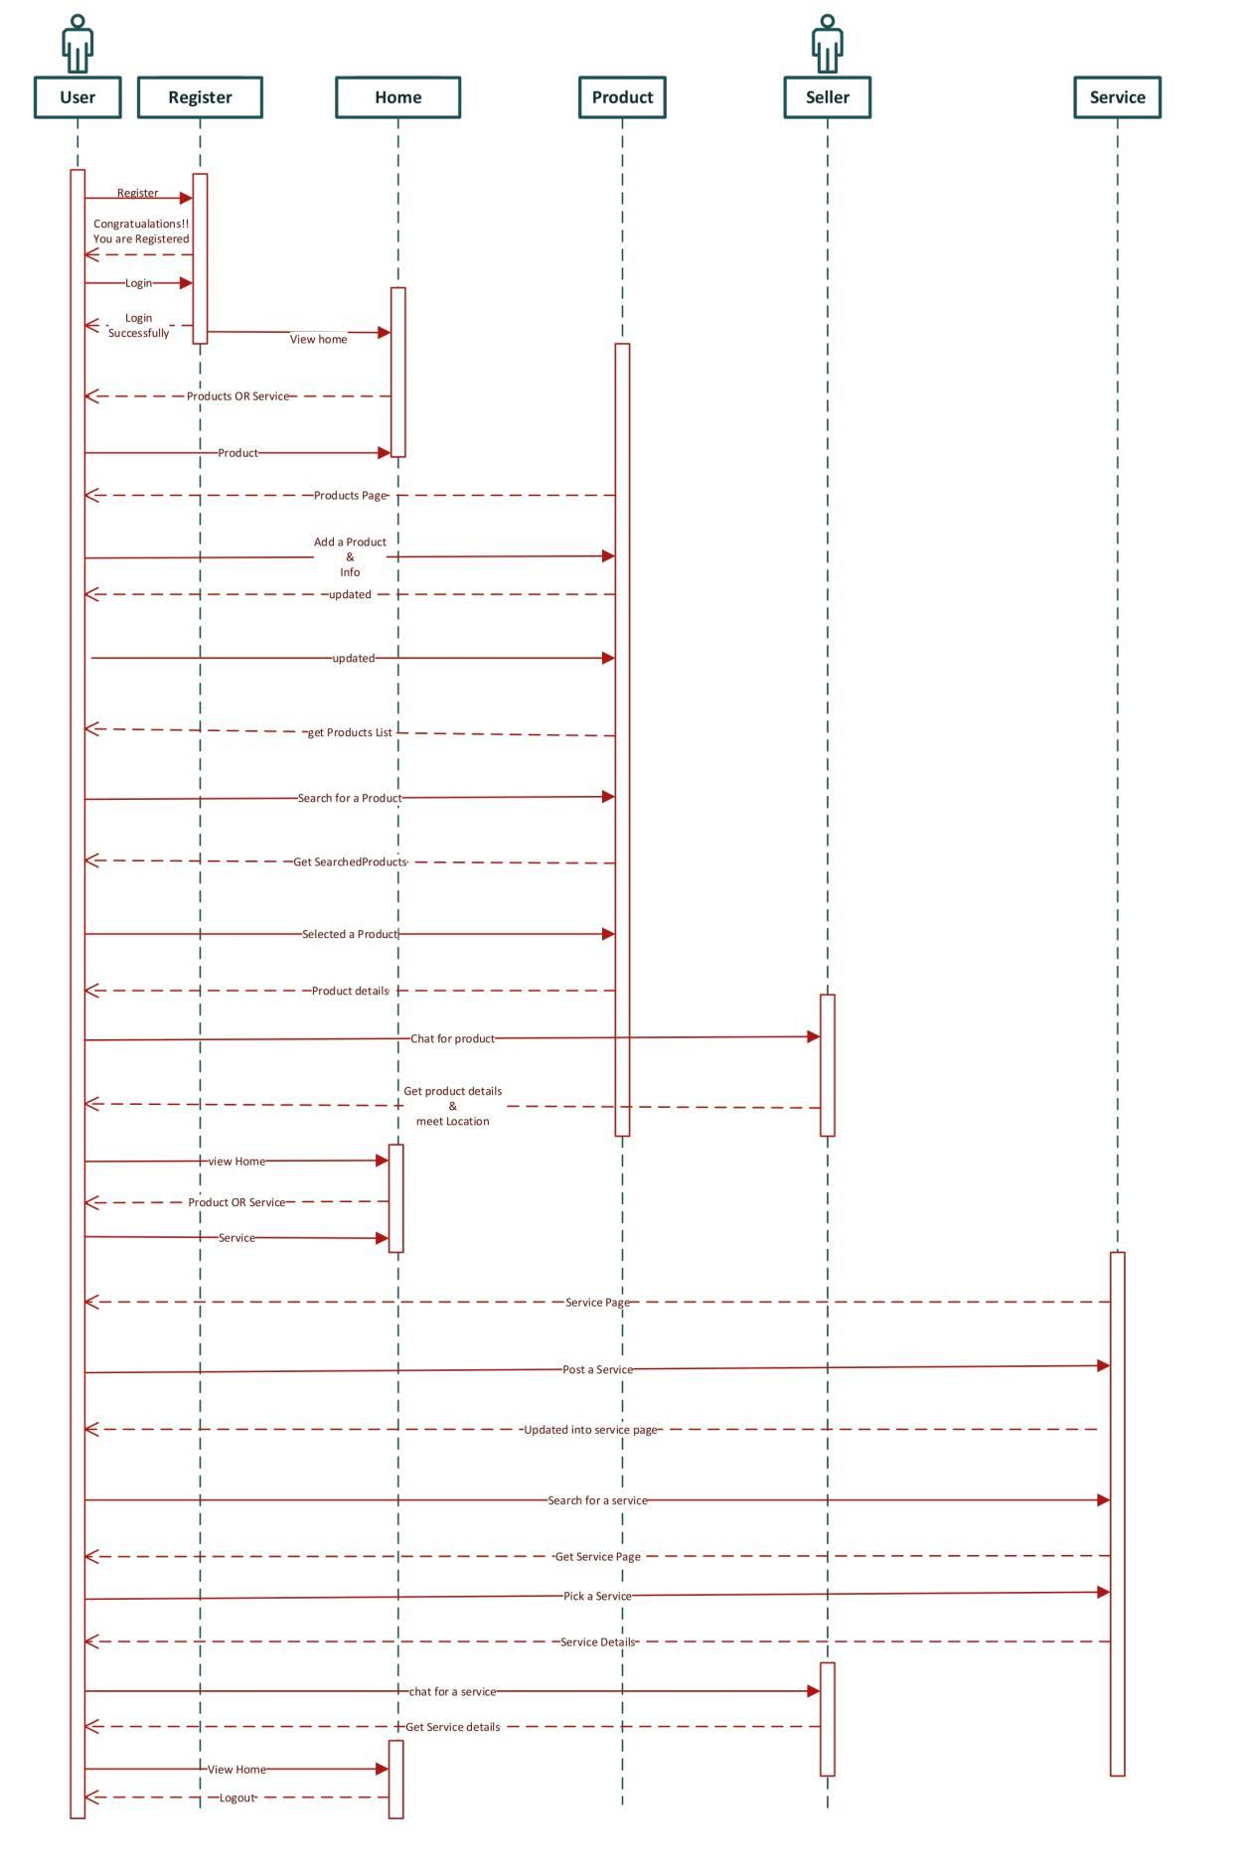

**8.0 Class Diagram:**

The class graph underneath portrays the stream of the framework and process.

Client Class had factors, for example, User Name, Email, Password, Phone number. These points of interest are utilized for enlistment. Post enlistment client can login utilizing Email and Password. At that point the framework approves the qualifications utilizing Authecation work and diverts the client to Home Page.

On the Home Page, two functionalities are Provided which are Products and

Administrations. Client can choose one among them at once. On snap usefulness is empowered for both and they divert the client to the separate pages.

Item Page: It comprises of two functionalities, buy a Product, Sell a Product. Benefit Page: Post a

Service, pick a Service functionalities are given.

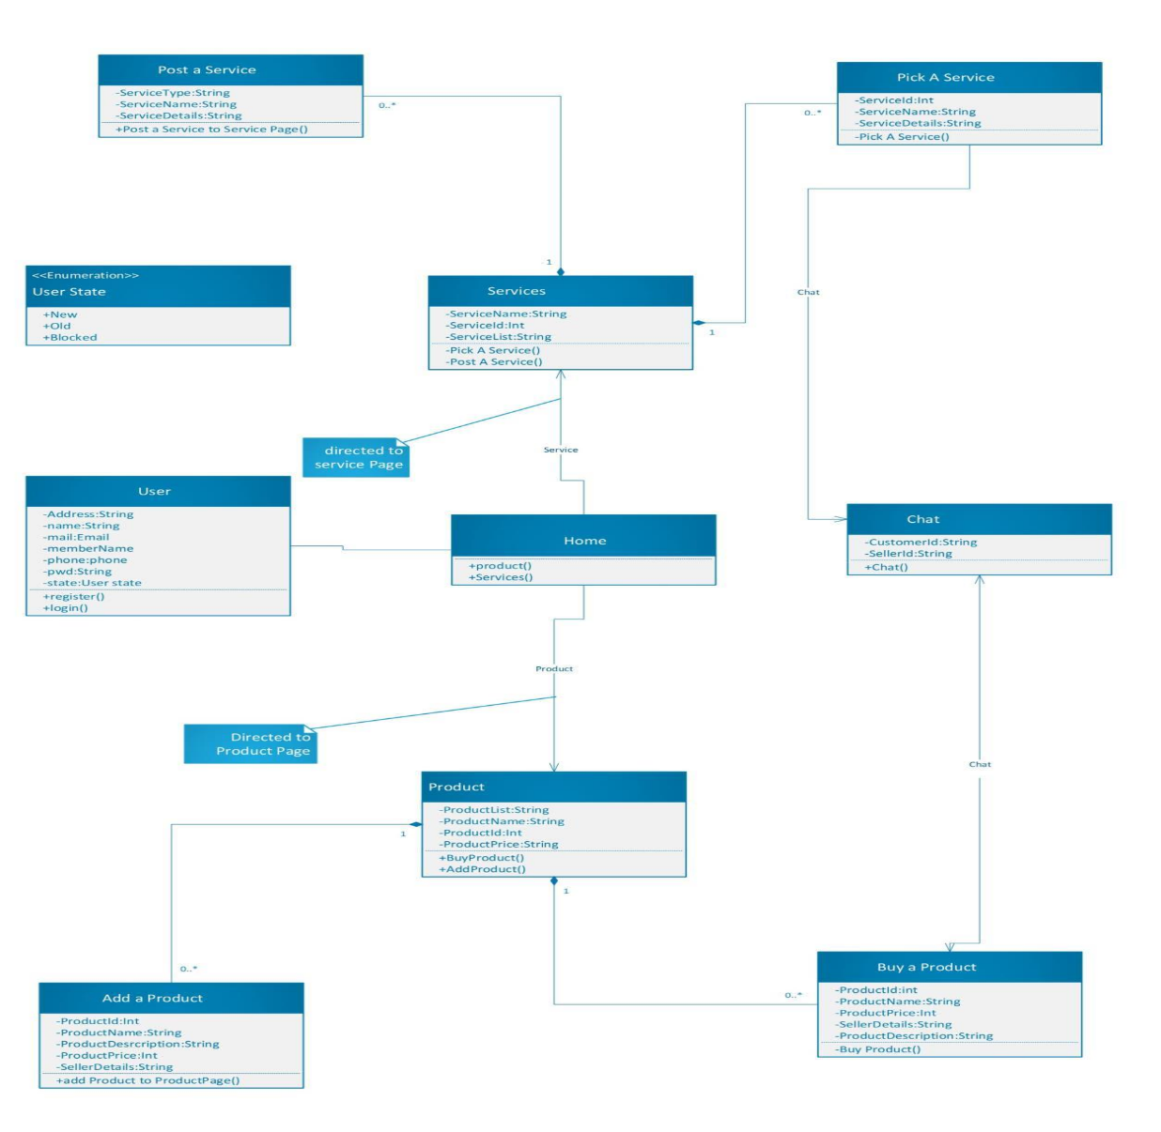

9.0 State Diagram

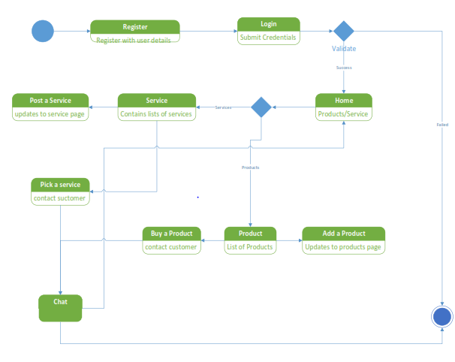

10.0 Mock Ups

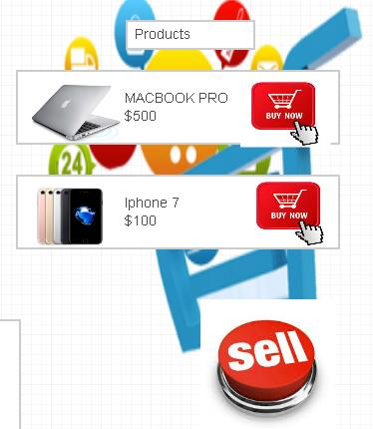

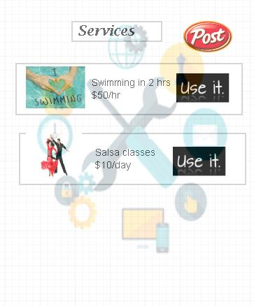

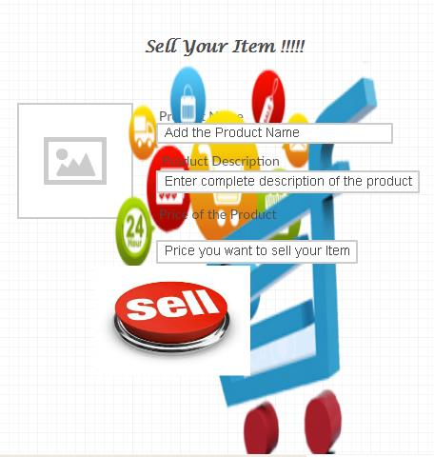

Initially Designed Mock ups.





11. Deployment:

After code is build, gradle scripts are Run, and deployed into OnePlus 3 android mobile Phone.

Recent Developments:

Connection to Database.

User credentials, personal Details, All available Products and Services are Stored globally at Mlab, Mongo DB.

**12. Project Management**

**Increment 4:**

**12.1 Functionalities to be implemented:**

* Plan the increment part and prepare necessary documentation.
* Implement the additional features for the Products & Services screen.
* Validate the Products & Services functionality of the RooKart application.
* Validate the DB functionality for the RooKart application.
* Re-design the User Interface for Products & Services screens.
* Integrate the RooKart Products & Services functionality & Validate the end-to-end functionality.

**12.2 Burndown chart:**

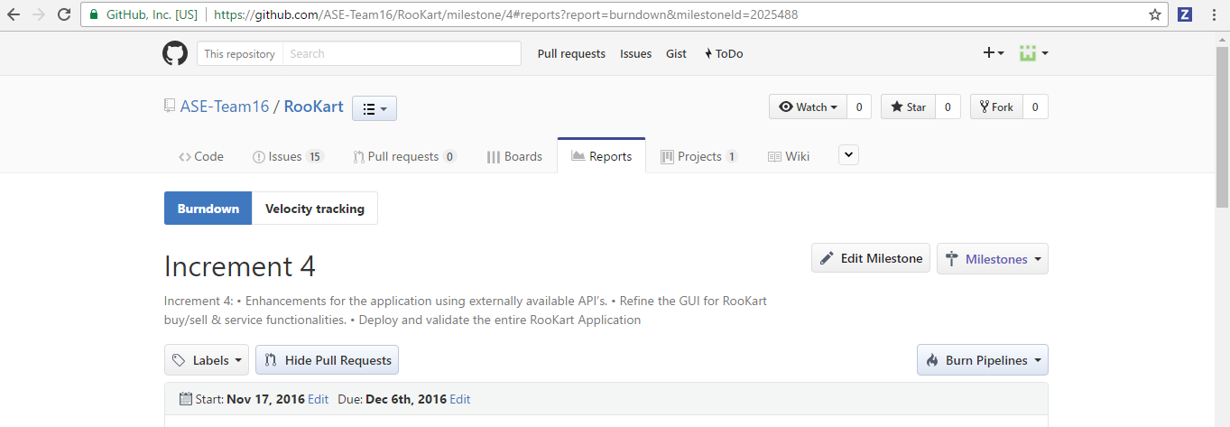

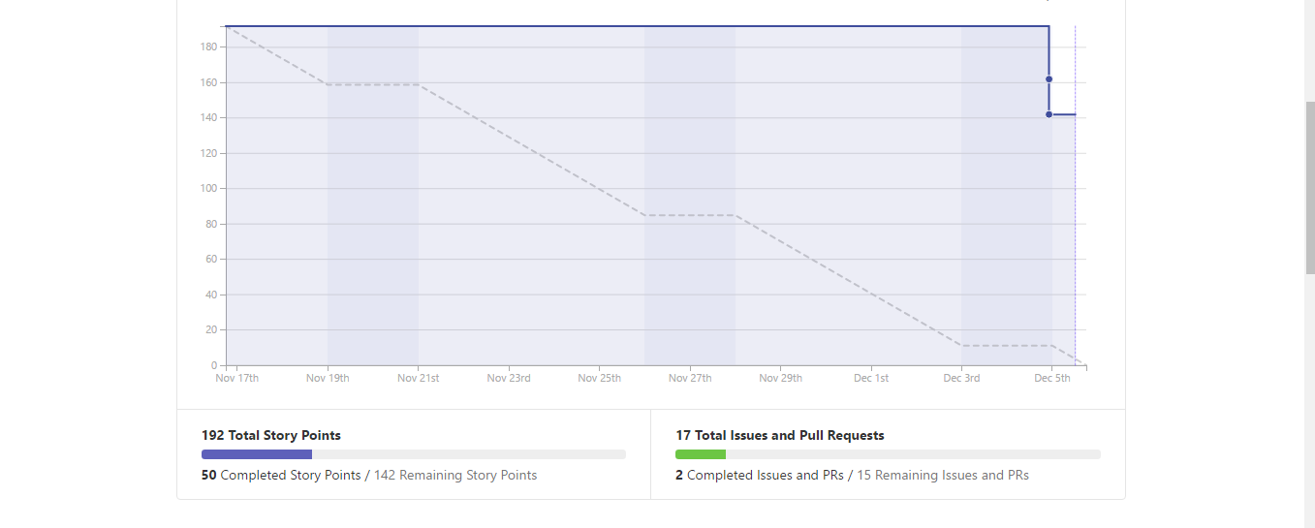

**12.3 User stories:**

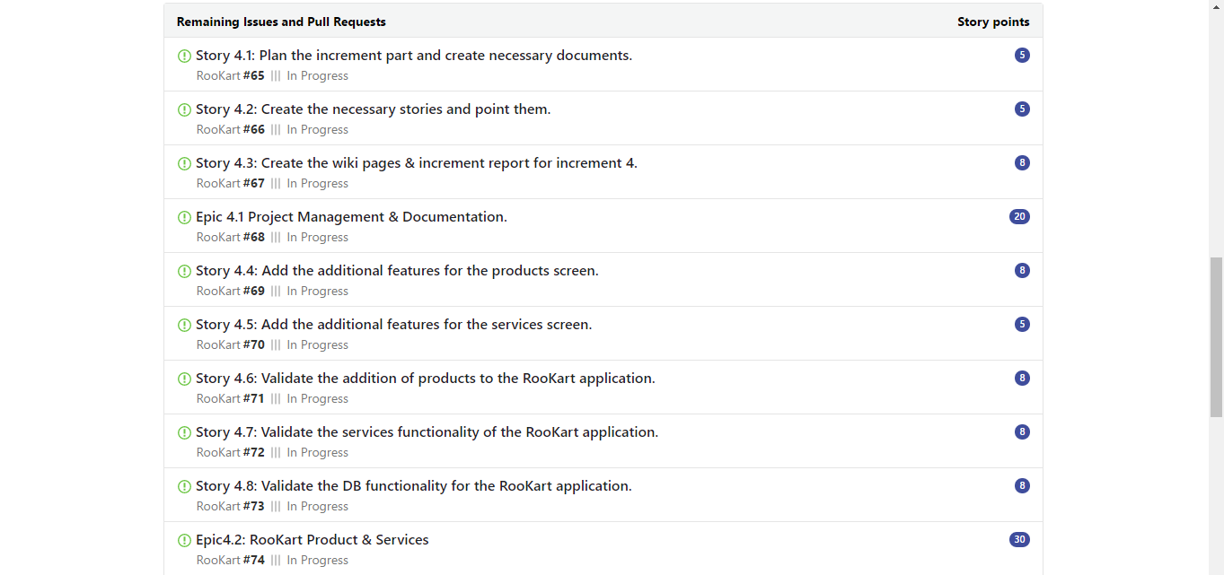

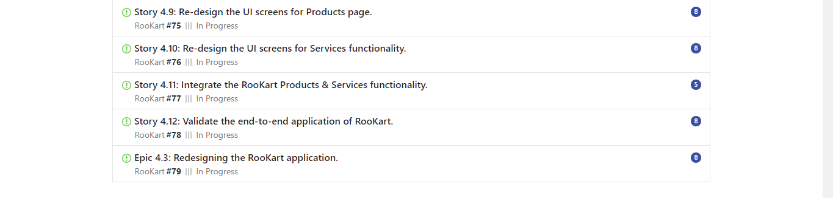

**12.4 RooKart Project Implementation:**

**12.4.1 Increment plan:**

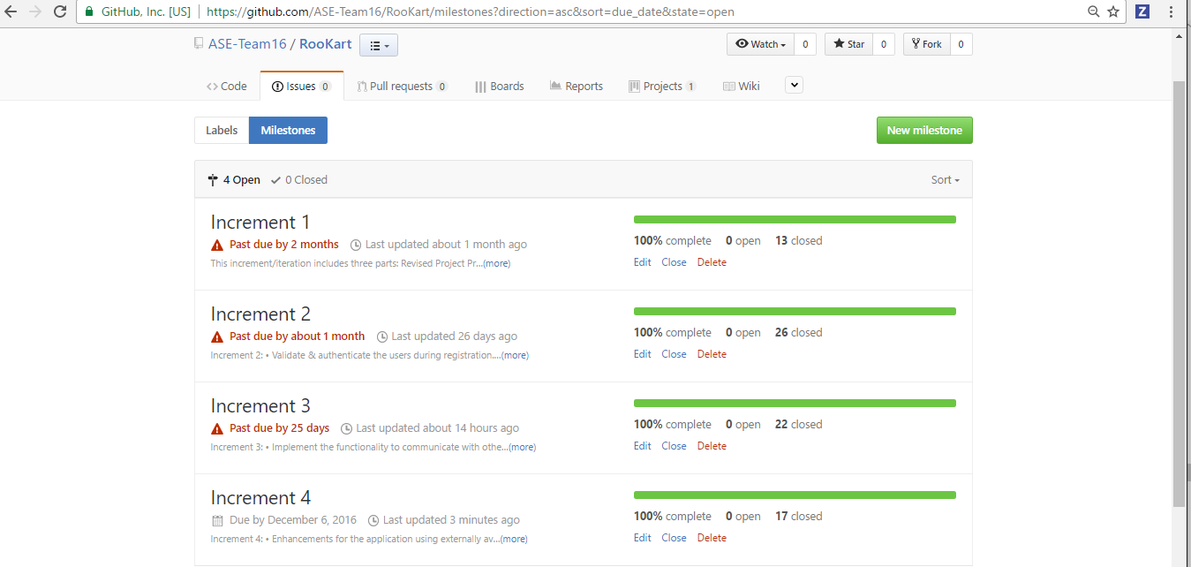

**12.4.2 Velocity of the Increments:**

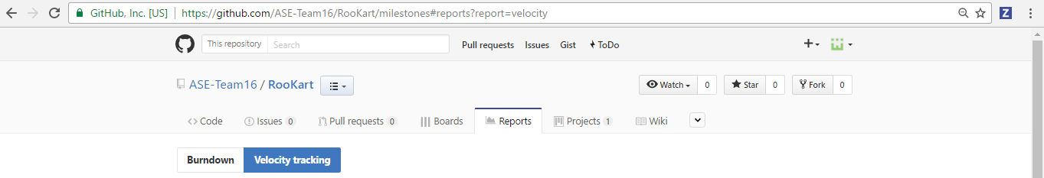

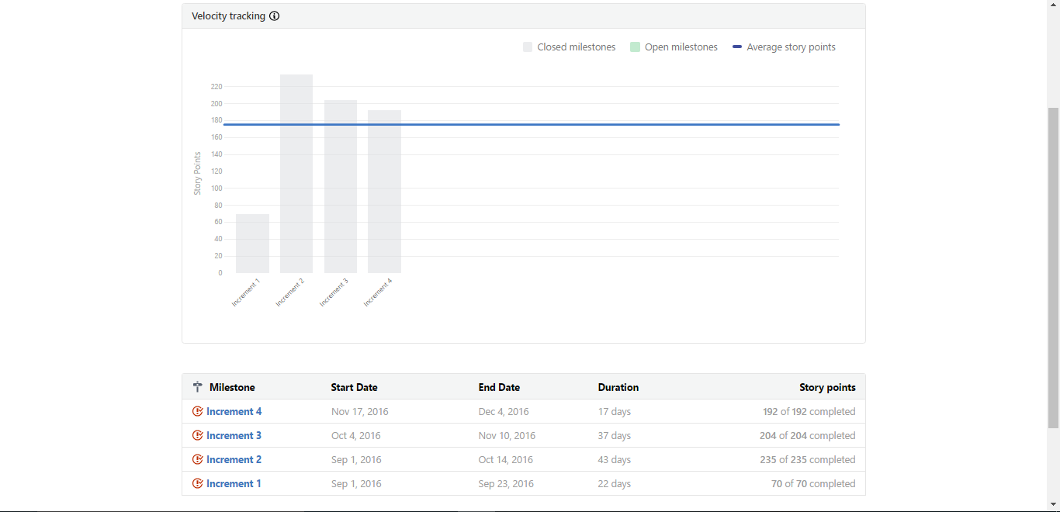

**12.4.3 Summary report:**

|  |  |  |  |  |
| --- | --- | --- | --- | --- |
| **Increment Phase** | **No. of Stories implemented** | **Total no. of Story Points** | **Start date** | **End date** |
| Increment 1 | 17 | 70 | 1-Sep-16 | 23-Sep-16 |
| Increment 2 | 22 | 235 | 24-Sep-16 | 14-Oct-16 |
| Increment 3 | 26 | 204 | 15-Oct-16 | 16-Nov-16 |
| Increment 4 | 13 | 192 | 17-Nov-16 | 5-Dec-16 |

13. Unit Testing:

14. Youtube URL: Please find the Rookart Application Video on Youtube.

Link in GITHUB:

**14.** Bibliography & References:

1. Github.com

2. Android Studio

3. Google Maps API.

5. Stackoverflow.com

6. Ebay.com

7. Quikr.com

8. Phase 1, Phase 2, Phase 3 Report Document.

9. Umkc.edu

10. Mongo DB